**CYCLOMATIC COMPLEXITY -1**

**PROGRAM:**

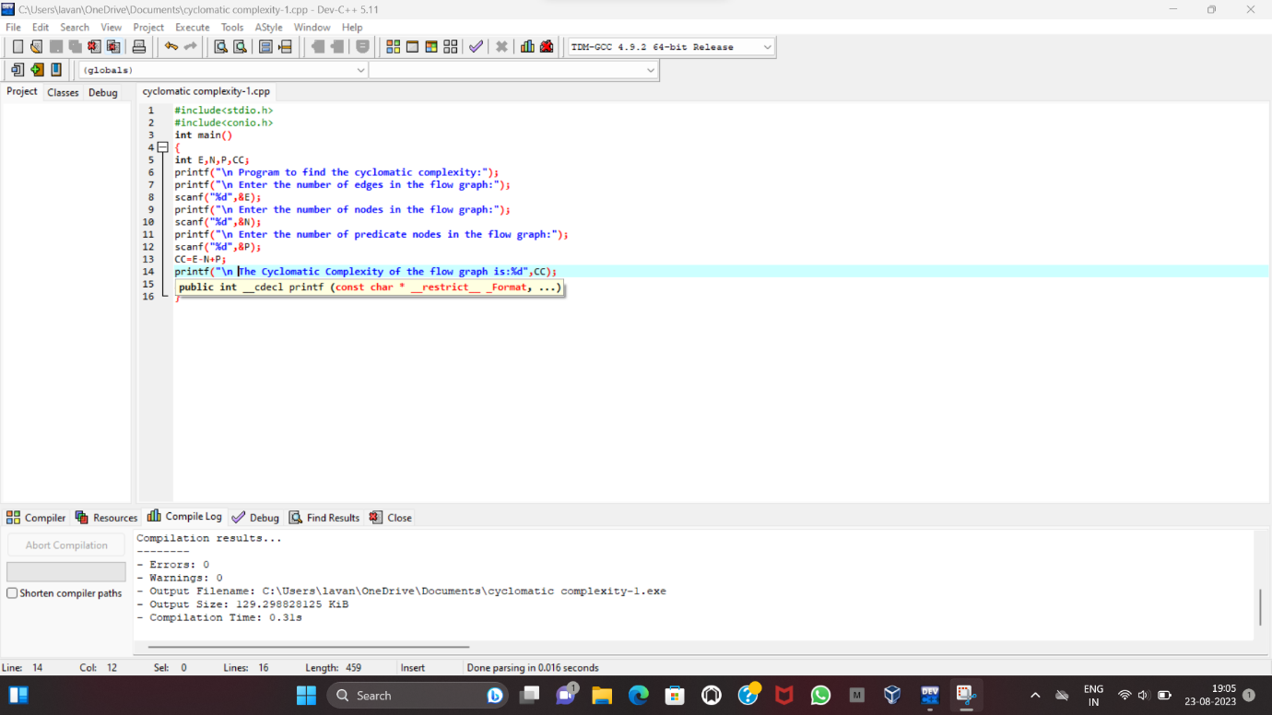

**OUTPUT:**

